Woodland Soccer Club  Affiliated with: US Club Soccer - C.Y.C.A.N - U.S.Y.A - U.S.S.F. & F.I.F.A  P.O. Box 1746 Woodland, California 95776 | 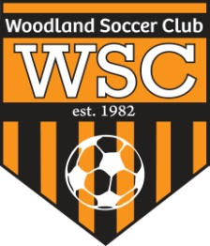

WSC Club Meeting
Wednesday, May 9, 2012

CALL TO ORDER:

Meeting called to order at 7pm

ROLL CALL:

APPROVAL OF MINUTES:
Motion to approve made by
Motion passed unanimously.
PRESIDENT REPORT:
- Consider shutting down all practices on meeting nights to ensure all coaches show up.
- Tournaments- Sunshine Classic Aug 18/19- U11- U16 Boys and Girls for Gold and Silver. WSC teams pay half and if they fill their age slot bracket, they play for free. Trophies for 1st and 2nd place only.

COMMITTEE REPORT:
- Recreational coaches are required to have a F license.
- NorCal will be having a class in August. This class will give coaches the required units needed per year.
- Registration/ Fundraiser at Steve’s Pizza on May 30th from 4-9pm
- WHS field repair on Friday, May 18 from 6-8pm
- Dixon Soccer Club can buy Gatorade for $6 per case
- U6 Academy- Able to form 2 fall teams for U8
- Fausto to look into setting up a WSC fundraiser- Possibly at the Community Center. Food, Silent Auctions, Carnival style

FIRST VICE REPORT:
- Uniforms- Comp teams will have custom Nike and Rec teams will have the $25 Kombat line.

HEAD COACH REPORT:

HEAD REFEREE REPORT:

TREASURER’S REPORT:

REGISTRAR’S REPORT:

SECRETARY’S REPORT:

OLD BUSINESS: None

NEW BUSINESS:

GOOD OF GAME:

ADJOURNMENT:
Motion to adjourn by
Meeting adjourned at

NEXT MEETING:

