Woodland Soccer Club  Affiliated with: US Club Soccer - C.Y.C.A.N - U.S.Y.A - U.S.S.F. & F.I.F.A  P.O. Box 1746 Woodland, California 95776 | 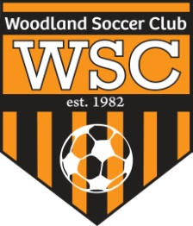

WSC Club Meeting
Wednesday, December 11, 2012

CALL TO ORDER:

Meeting called to order at 7pm

ROLL CALL:

APPROVAL OF MINUTES:
Motion to approve made by
Motion passed unanimously.
PRESIDENT REPORT:

COMMITTEE REPORT:
- HOLIDAY/ APPRECIATION DINNER.
- Kids will be allowed to field marshall at the state cup.

FIRST VICE REPORT:

HEAD COACH REPORT:

HEAD REFEREE REPORT:

TREASURER’S REPORT:

REGISTRAR’S REPORT:

SECRETARY’S REPORT:

OLD BUSINESS: None

NEW BUSINESS:

GOOD OF GAME:

ADJOURNMENT:
Motion to adjourn by
Meeting adjourned at

NEXT MEETING:

